**Note：**

Please check the current FW version of the device.



For devices with current FW version equal to or higher than V274. You can skip Steps 1 and 2. You do not need to upgrade the .exe file. Can upgrade directly on the MM. (For devices with FW version lower than V274, please follow all steps strictly.)

**Modification FW please follow all steps strictly.**

1. To upgrade MD522S_V274_20190110. exe





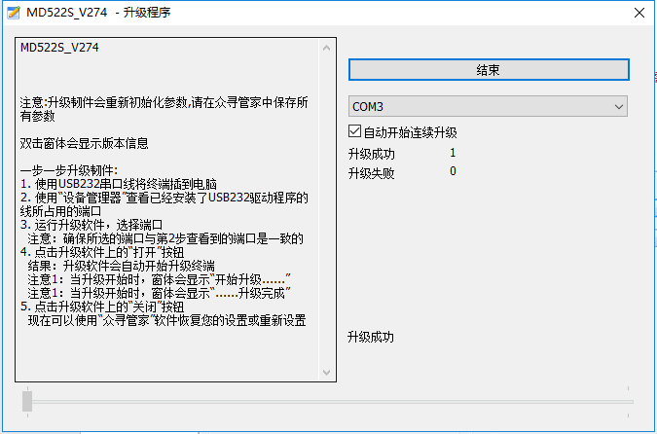

1. After upgraded, power off and restart the device (must to wait for all the indicator lights to be turned off before power on). Then repeat it. Needs to power off and restart the device again until MM reads the full version number.

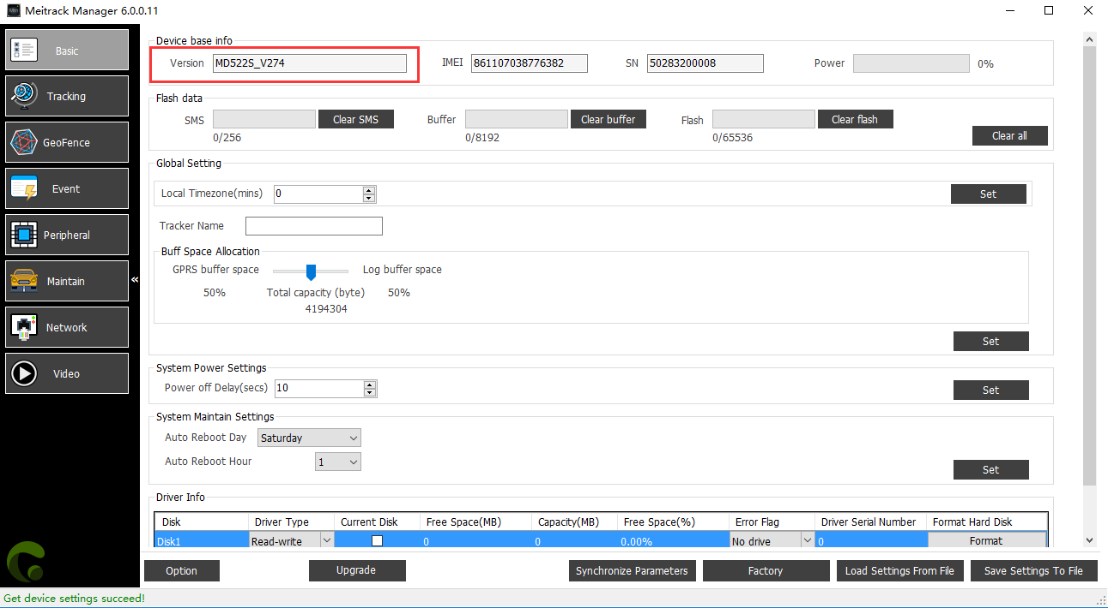

1. Find a U-disk, then save this file in the U-disks. (batter remove all other files avoid disturb)

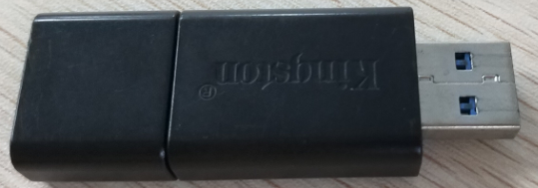

1. Connect the U-disk with MD522S.

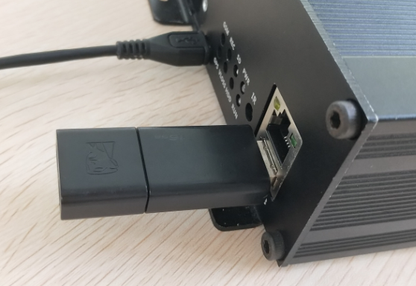

1. Connected ACC with Power. (Yellow cable)

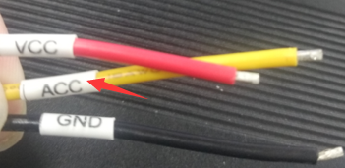

1. Use MM to upgrade the program saved in the U-disk. (MD522S_G4PG3W1_V44.274)
2. Click “Upgrade” button in below

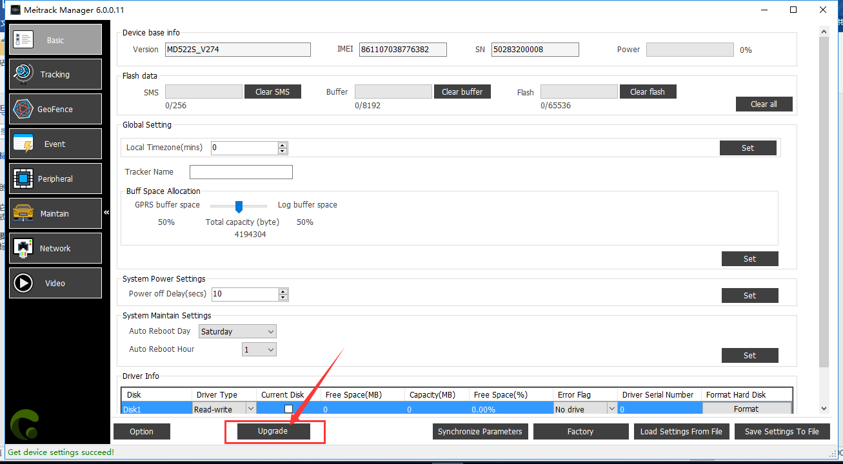

1. Click”get file list”

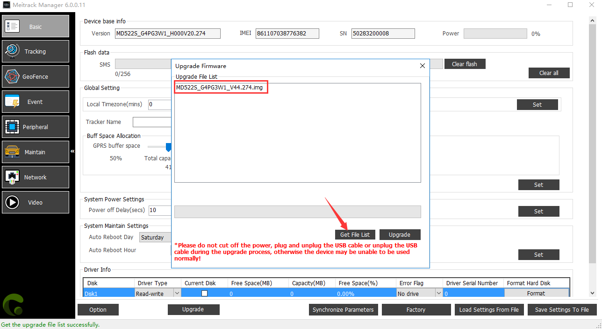

1. Choose the program and then click ”upgrade”

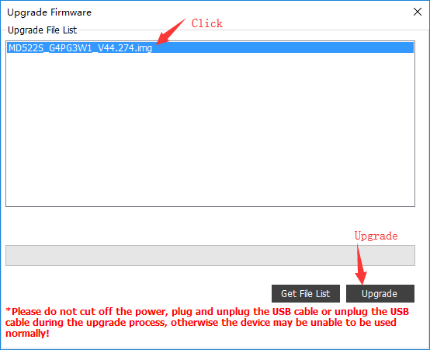

1. After wait 6-7 minute will upgrade success.

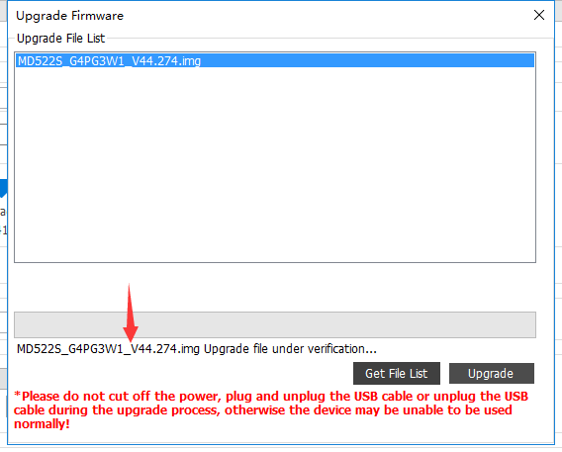

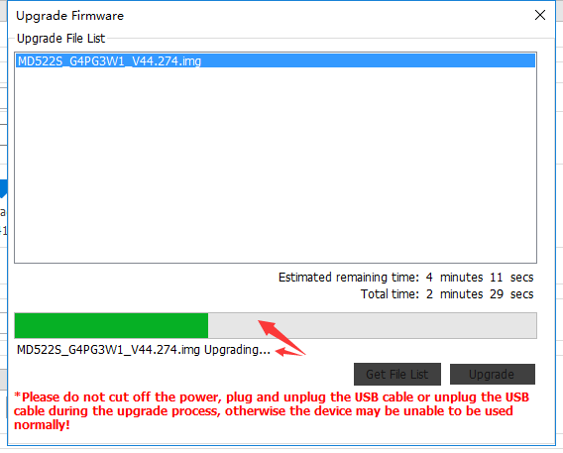 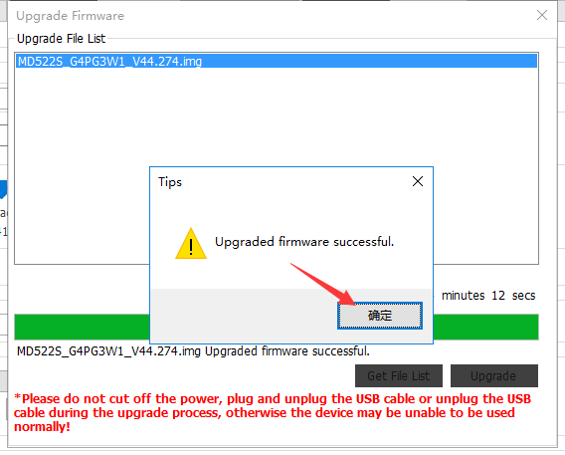

1. The version show on MM will not be updated until around 5S after the upgrade.

